Douglas
Emmett
Form CT-04
Bishop Square

To order keys and locks, please complete this form, have an authorized person sign it and return it to the Office of the Building.

Tenant Name: |  | Tower: ASB Pauahi
Suite No.: |  | Date:
Email: |  | Phone #:
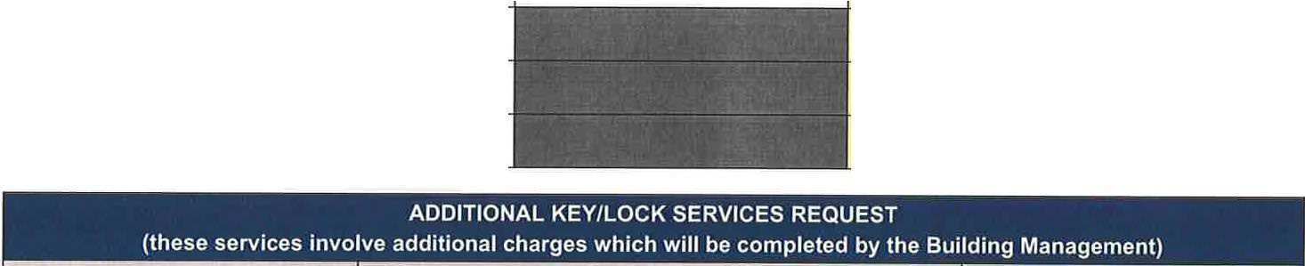
Location of Door | # of Keys | Key # (found at top of key) for Suite Entrance  & Interior Door only. | (For Building Management use only)
 |  |  | Cost per Key | Total Cost for Keys
Suite Entrance |  |  | $40.00
Interior Door |  |  | $40.00
Women's Restroom |  |  | $40.00
Men's Restroom |  |  | $40.00
Mailbox |  |  | $40.00

Location of Door | Request Type | Total Cost for Service  (For Building Management Use)
 | Rekey Change Lock/Keypad Code
 | Install Lock
 | Shipping

Your account will be billed in accordance with our standard practices for the requested services, including an administrative fee as applicable on third party charges. If you have any questions about how your charges will be calculated, please discuss them with us before submitting this form.

Tenant  Authorized Person: | Signature:
 | Type/print name & title:

BUILDING MANAGEMENT USE ONLY
Amount due: I$ | TLA #:
Signature: | Date:

Received by: ______________________________________________Date: ________________________

If you have any questions, please contact the Office of the Building:
Phone: (808) 545-7500 ~ Fax: (808) 523-6008 ~ Email: bishopsguare@douqlasemmett.com
1001 Bishop Street, Suite 750, Honolulu, HI 96813
rev 05/23

